**Abarar Sheikh**

**Futures:**

**1. Add Movies-Small Content management system**

**2. Rating System**

**3. Contact Us page and Google API**

1. **Movie Feature:**

Login to Admin page and Click on Add Movie

**Add movie** –**Admin Interface**

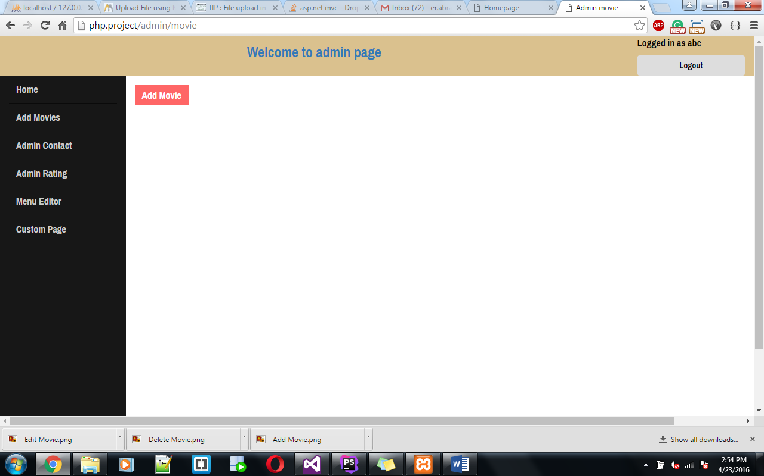

Click on Add Movie -> it goes to the **Add movie form.**

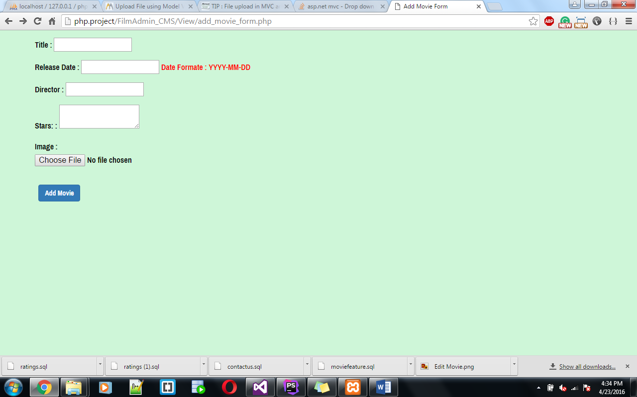

While adding movie all the fields are mandatory, if any field is missing it displays an error and won’t allow to add the movie.

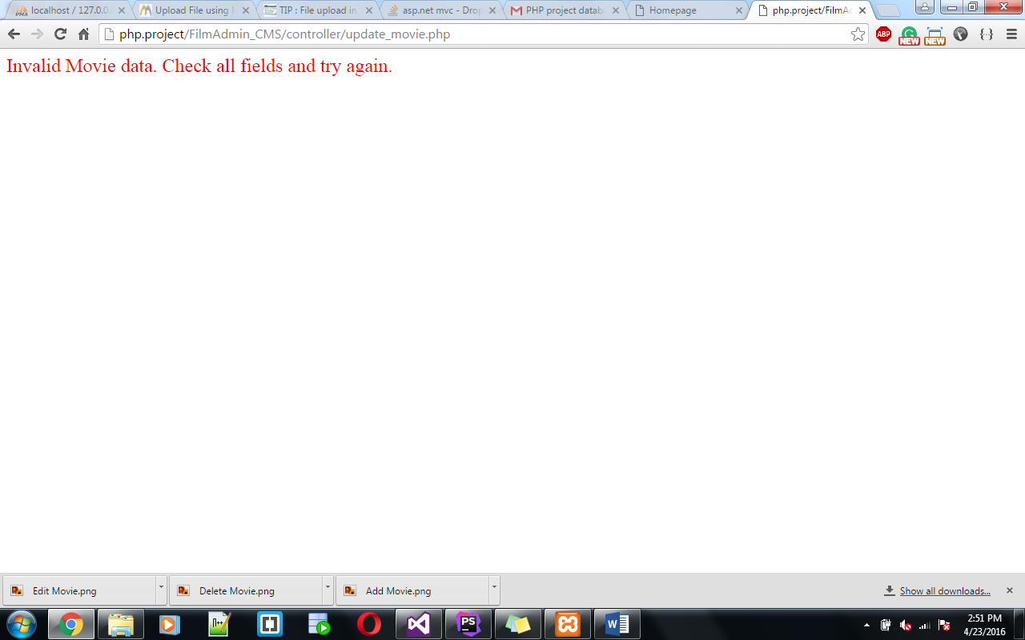

Fill All the Fields and Click on Add Movie Button.

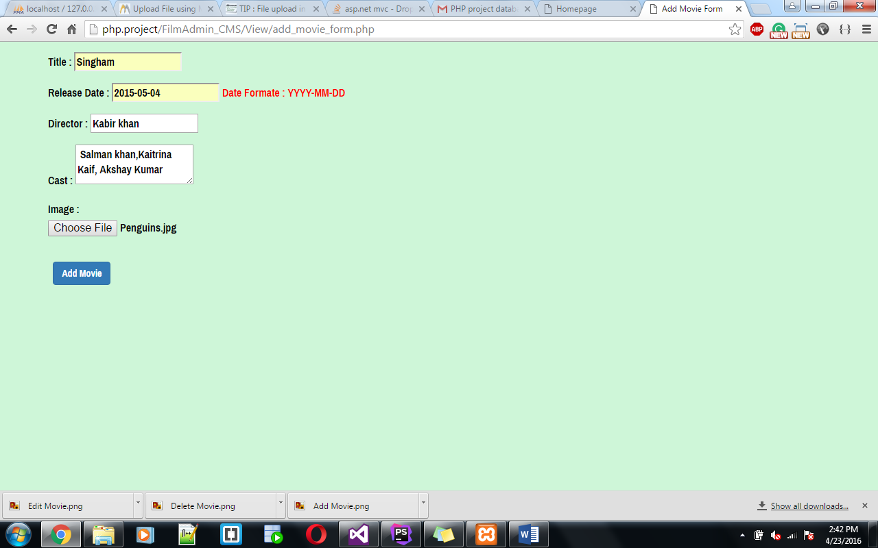

After adding movies it redirect to admin Home page. (If Image file is big and height is less than 400 PX it crop the image and add extra black space in height and then it will add the Images.)

Images are stored in path: php-project/Assets/mage/HomePage .

All Uploaded images stored by prefix name “ **thumb_ filename “.**

Add movie only allows “ **gif/jpg/png”**  image file format other than format it display below error.

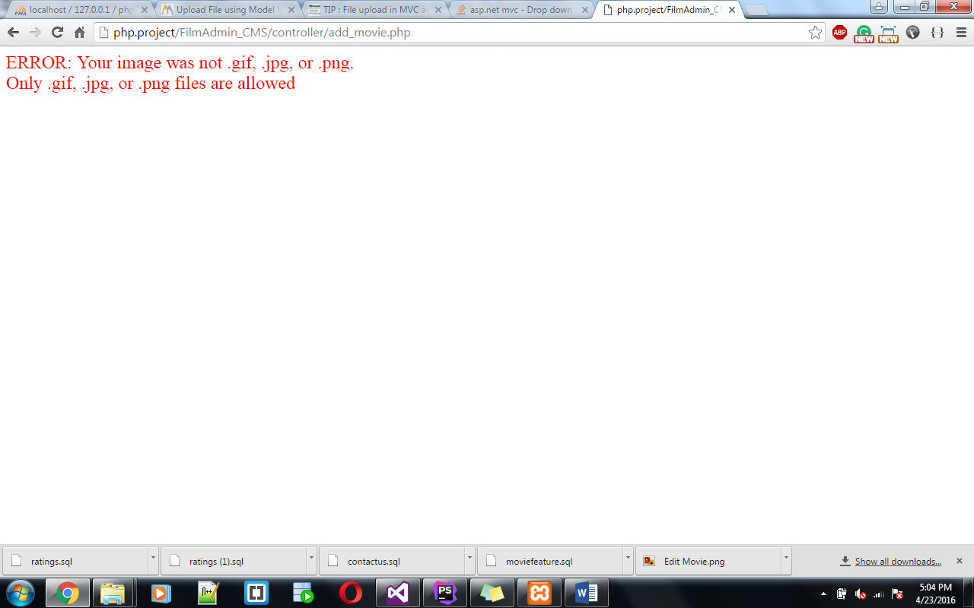

Once the movie added successfully it redirect admin to admin/home page.

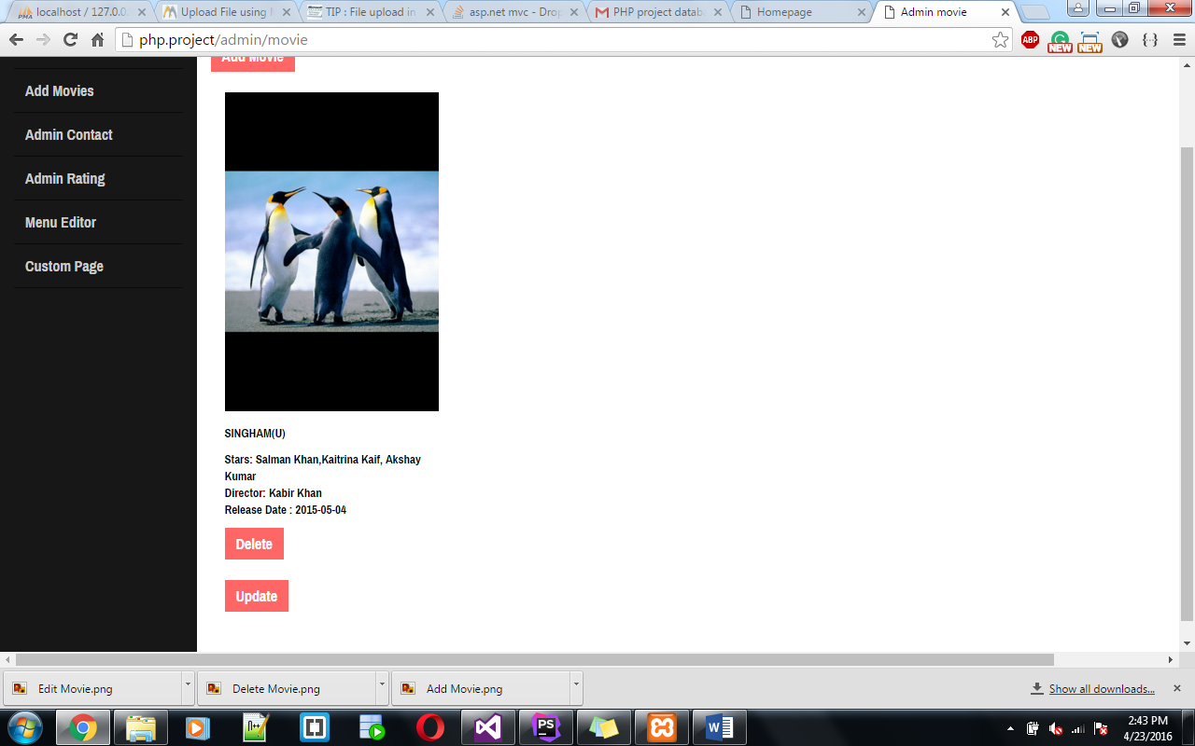

Also go and Check on **User Interface.** Movie also get added at user interface.

Movie Feature - **User Interface:**

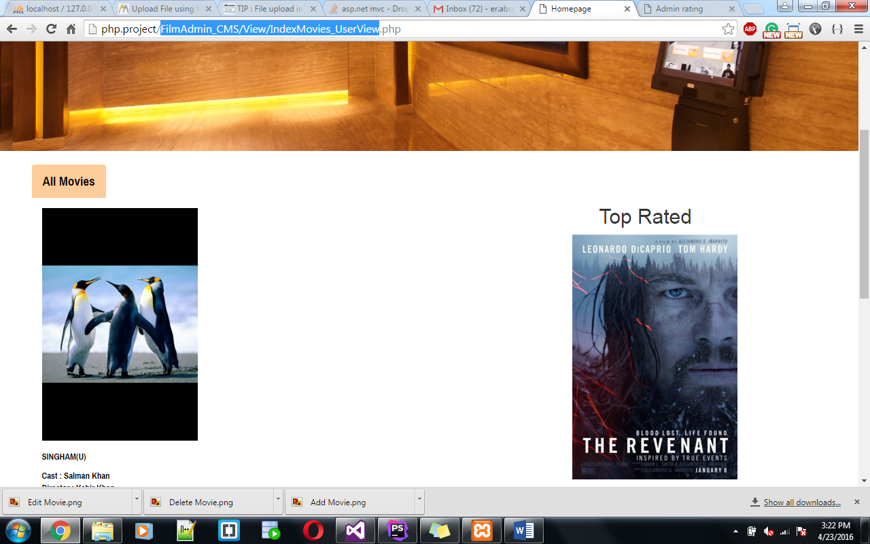

Now click on **Update Movies**.

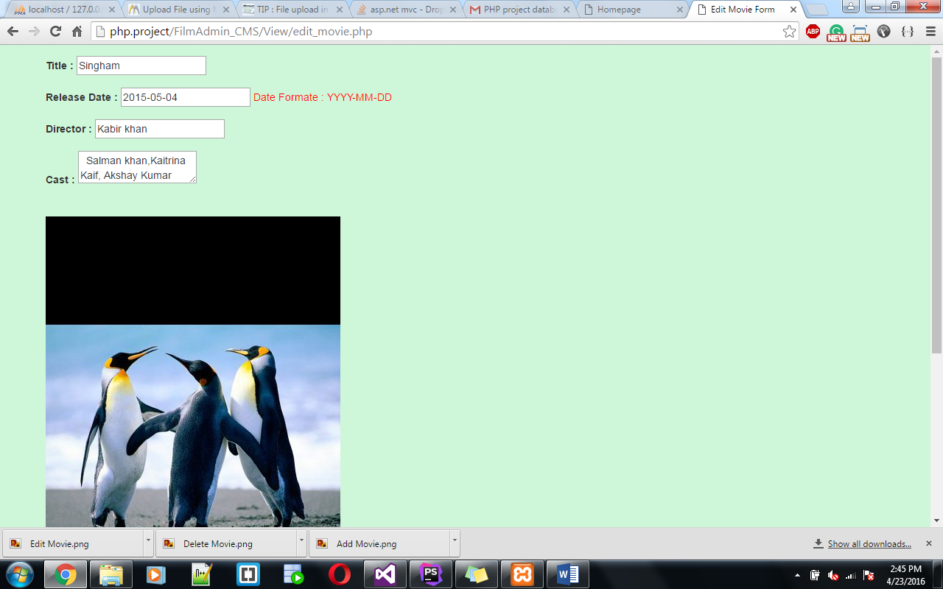

While updating if you left any field empty or if you don’t select image it throws an error.

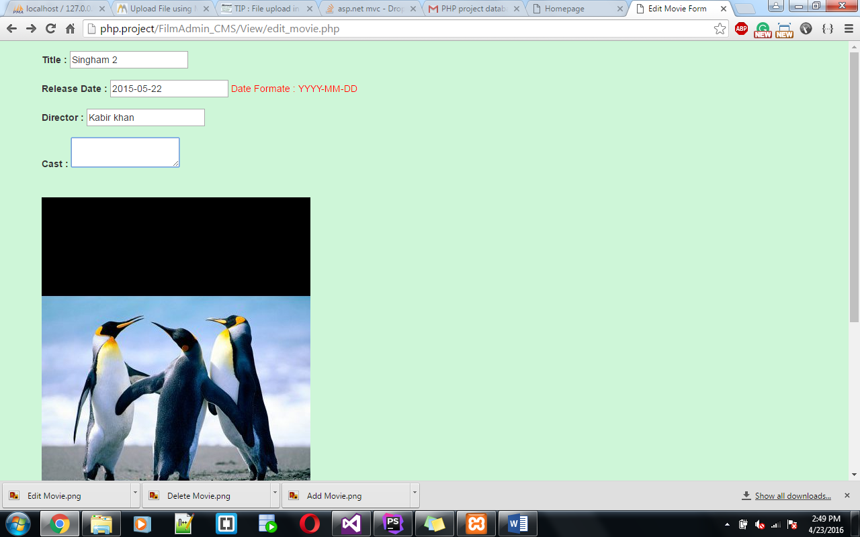

Click on **Update** will display the below error.



If you do not select image it shows below error.

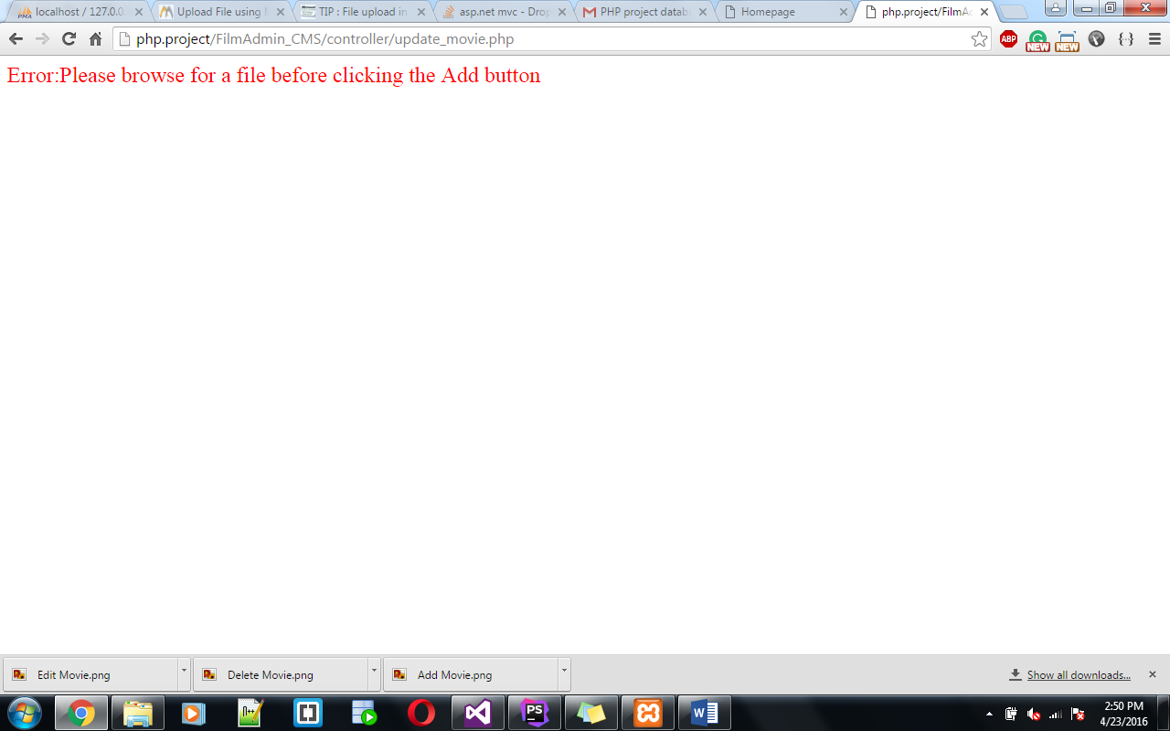

After editing it redirect to admin home page and now click on **Delete button**

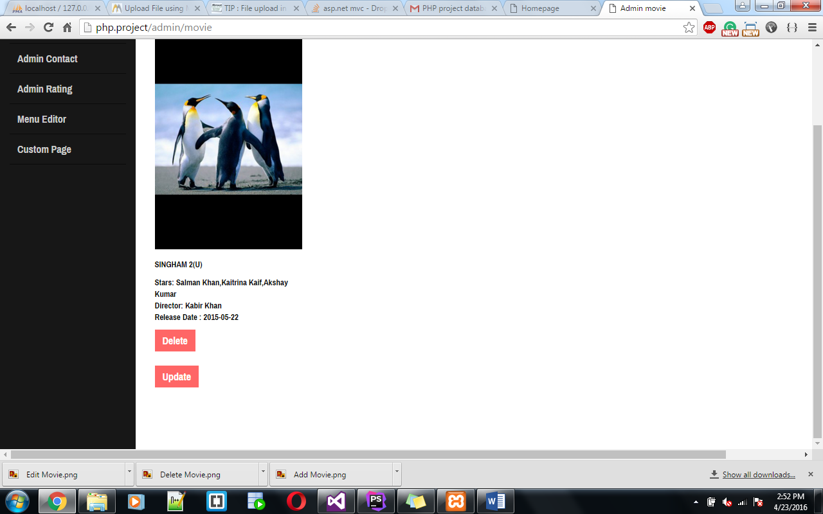

Click on **delete button** .it deletesthe Movie.

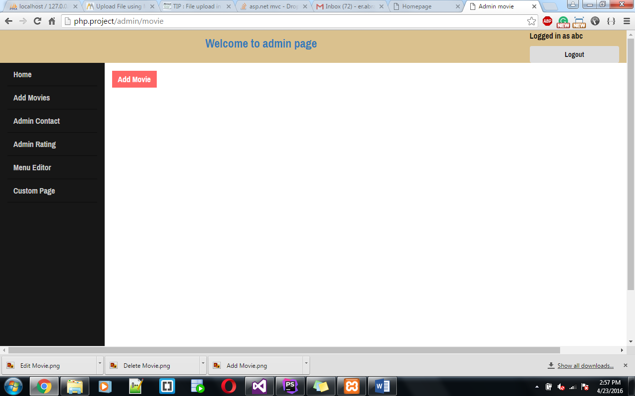

1. **Contact US Feature:**

**User Interface:**

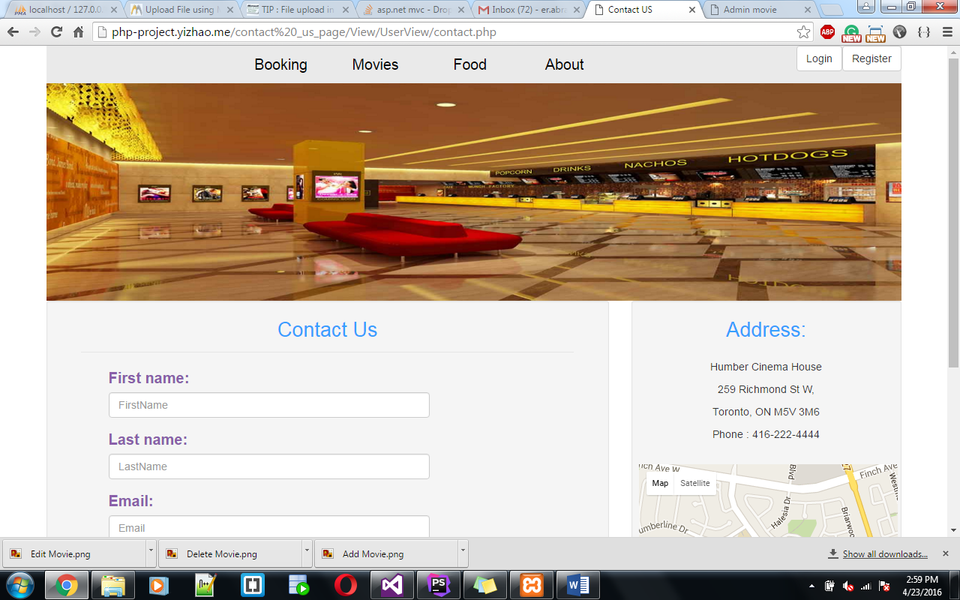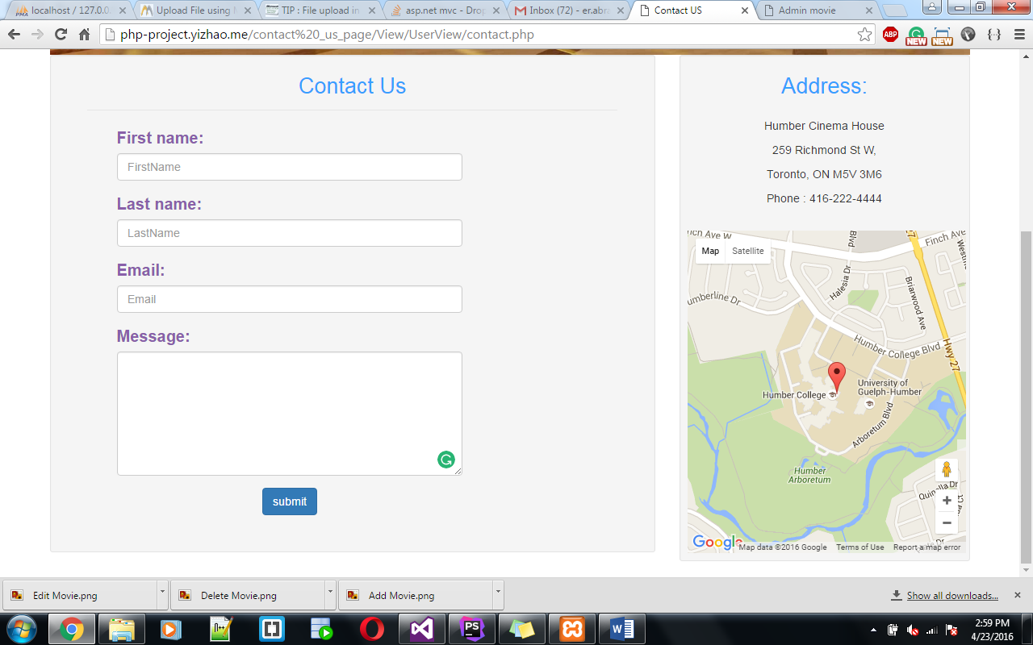

Click on submit button without entering anything shows below error.

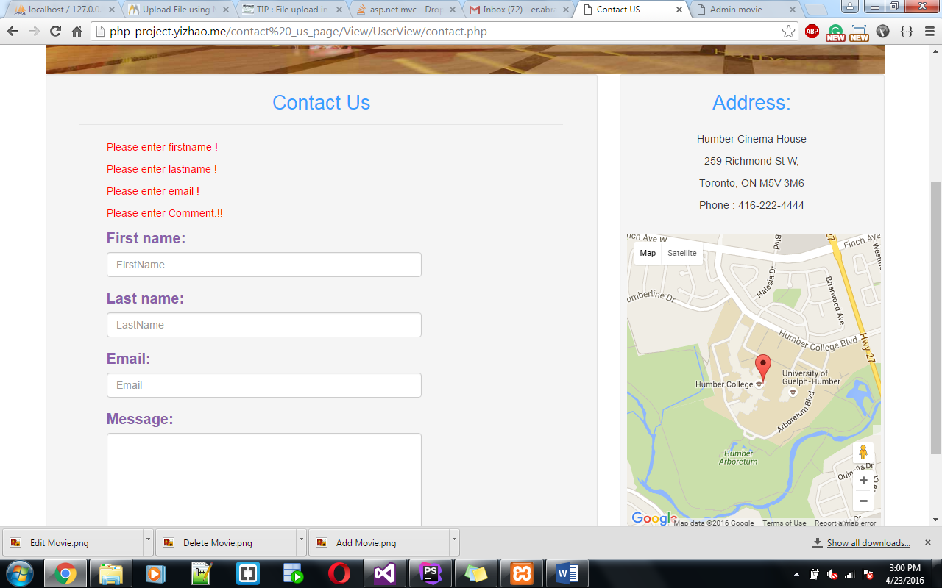

Fill the Form and click on submit button it will send a notification email to user’s email ID whatever user entered in Email field.

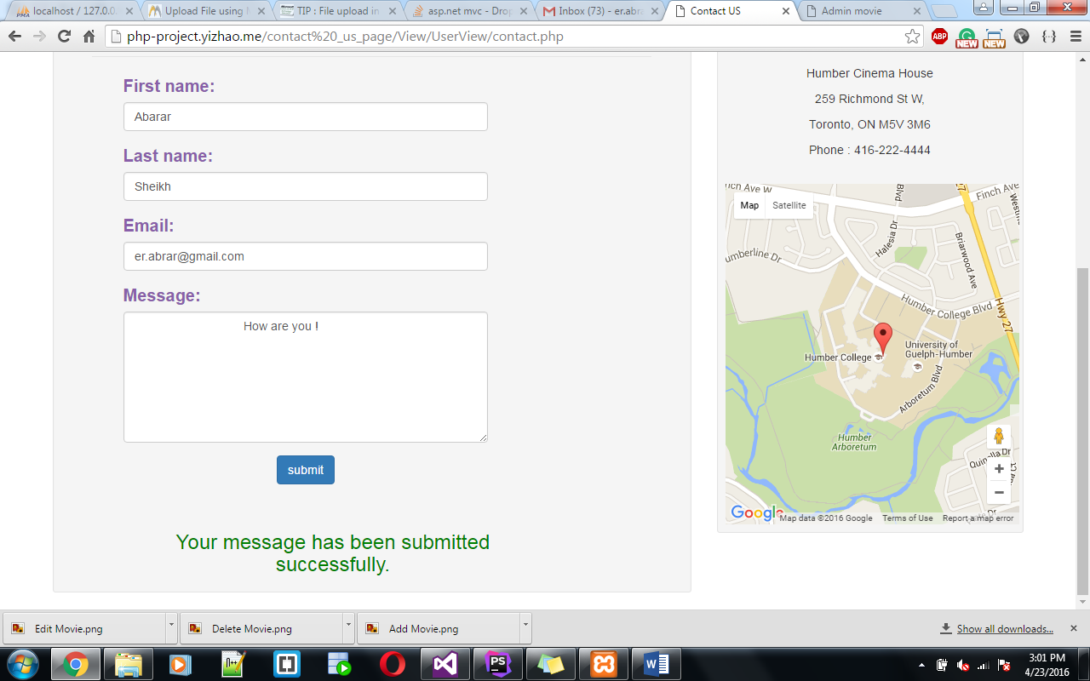

**Contact US Admin Interface:**

**Click on Admin Contact**

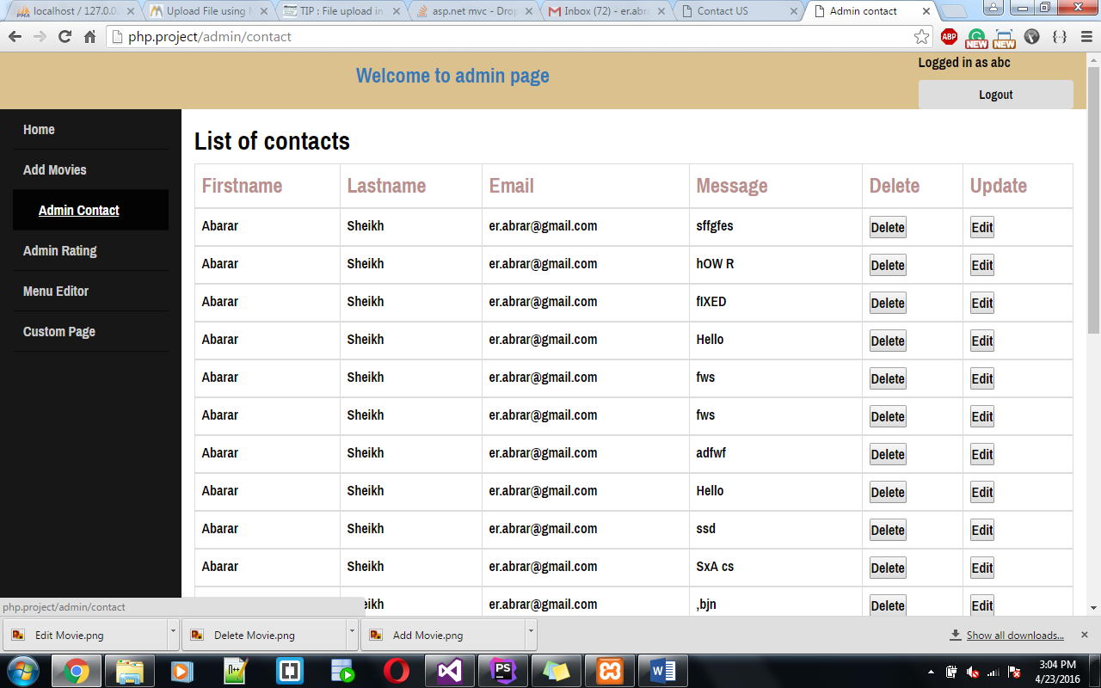

**Click on Edit**

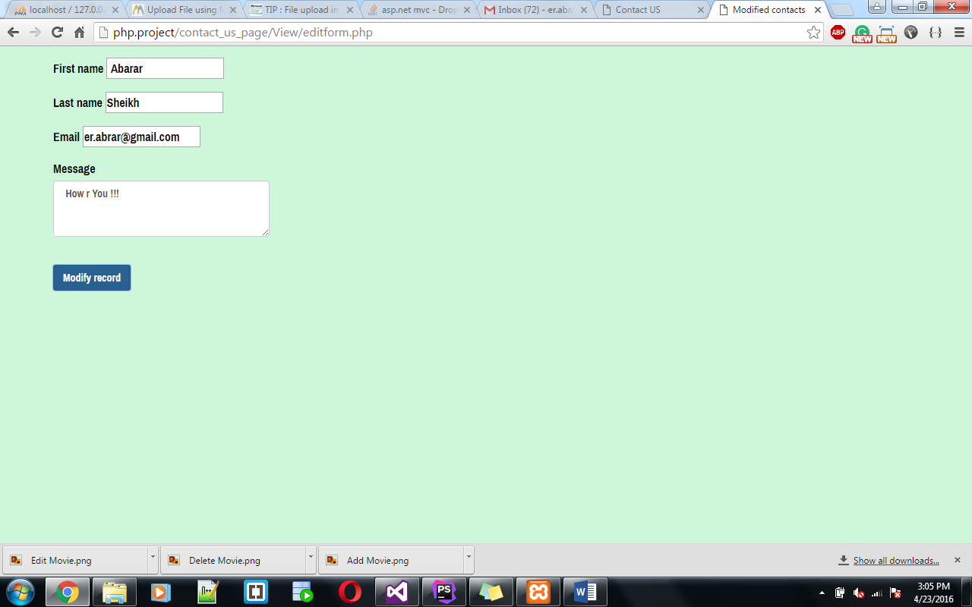

Click on **Modify record:**

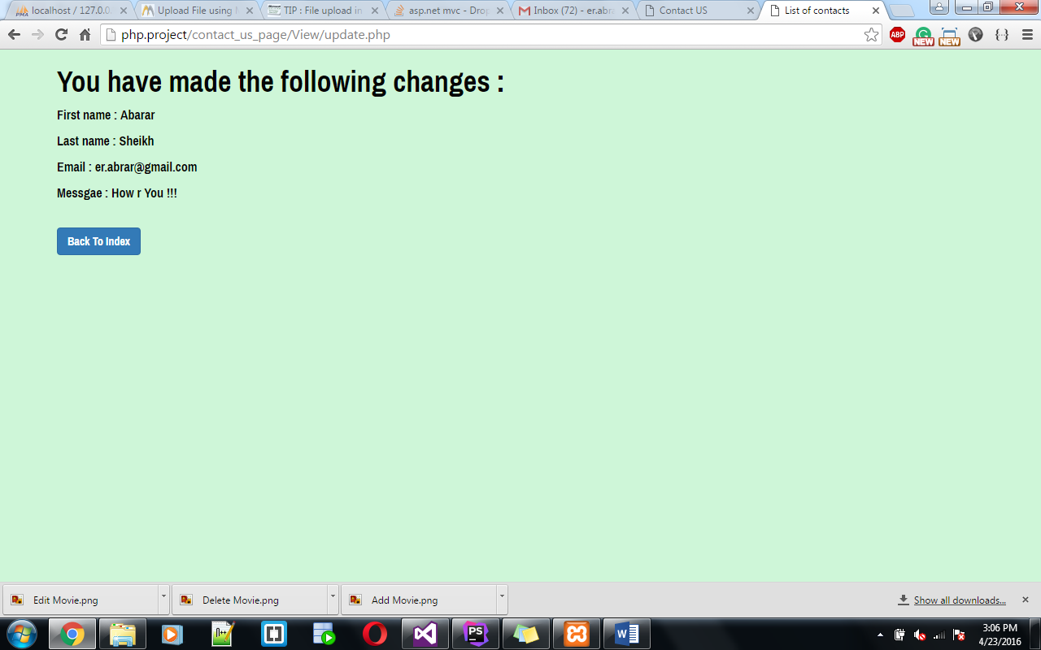

**Back to Index** redirect to List Contacts**.**

Click on **delete Button**

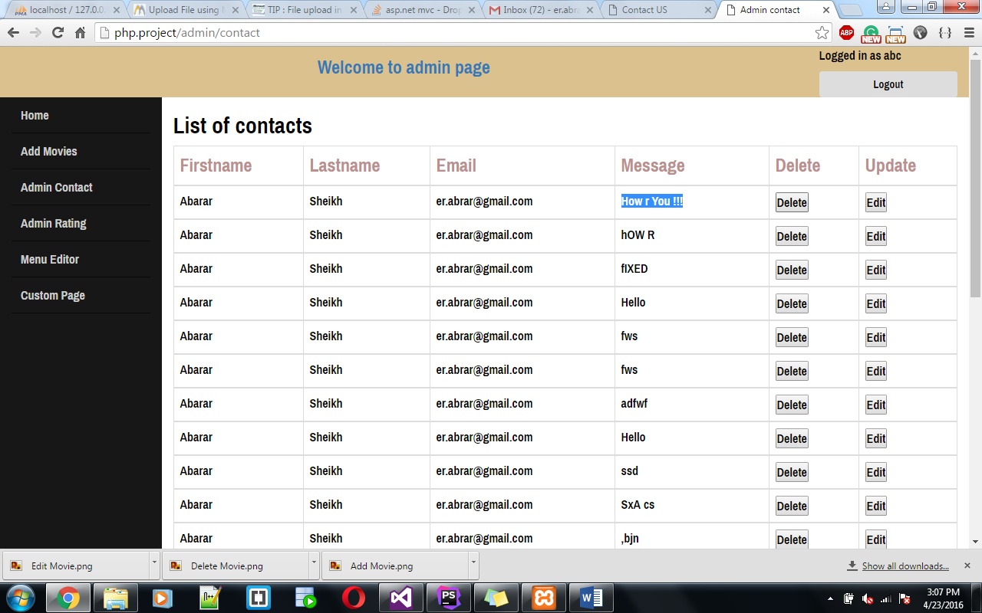

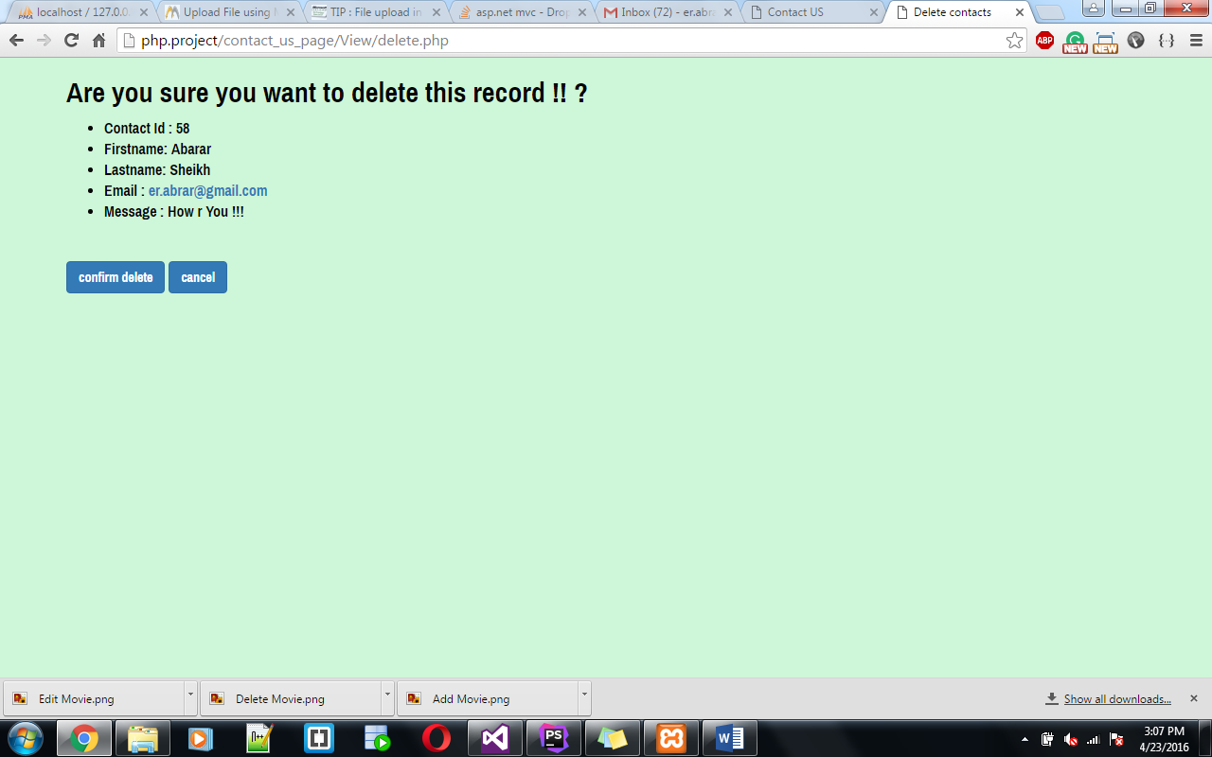

**Click on confirm delete**

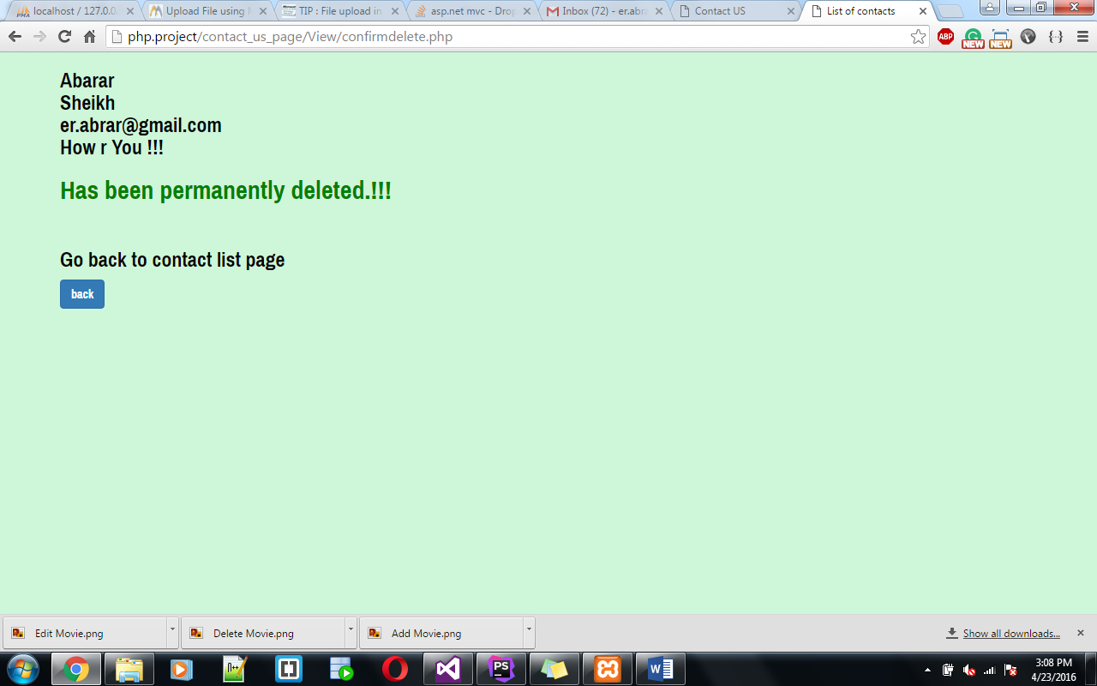

1. **Rating System Feature:**

**User interface:**

Rating System display with all the movies and when you add the new movie its get add automatically. Open FilmAdmin_CMS/View/IndexMovies_UserView.php display ratings with movies.

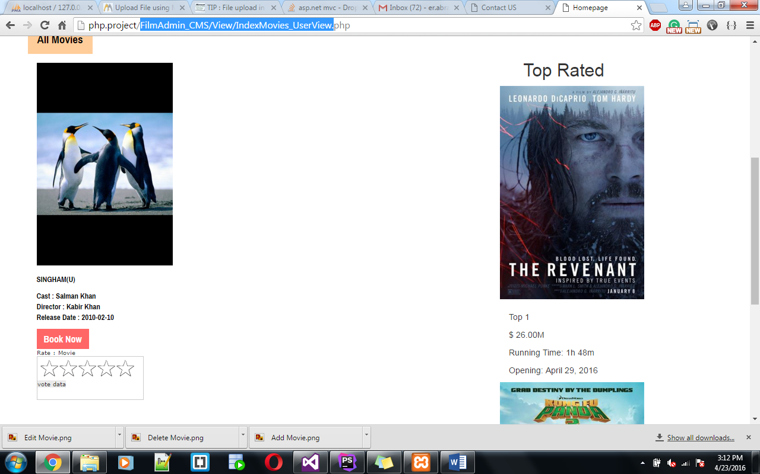

**Hover on Rating and click for rating**

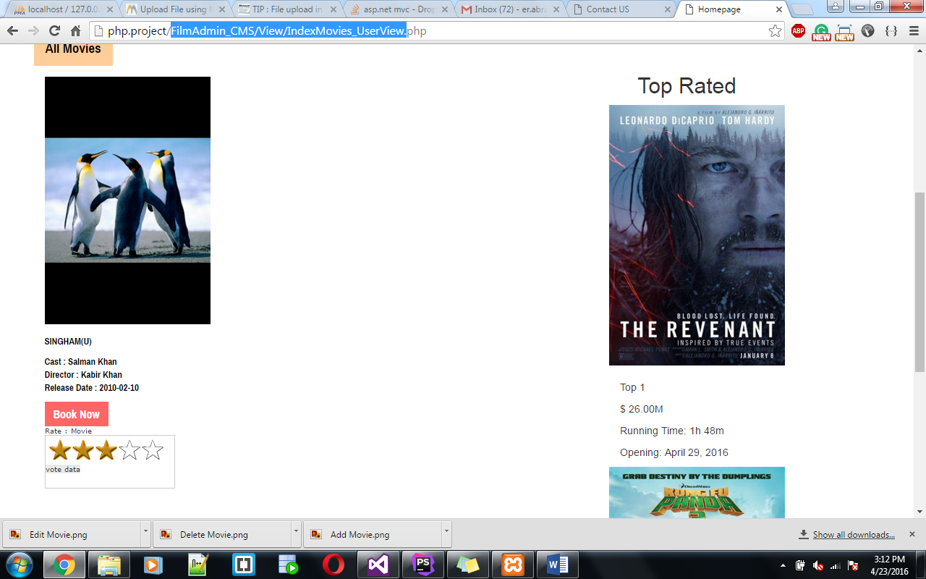

You have to Login to Rate the Movies.

If you click on rating without login will show below error message.

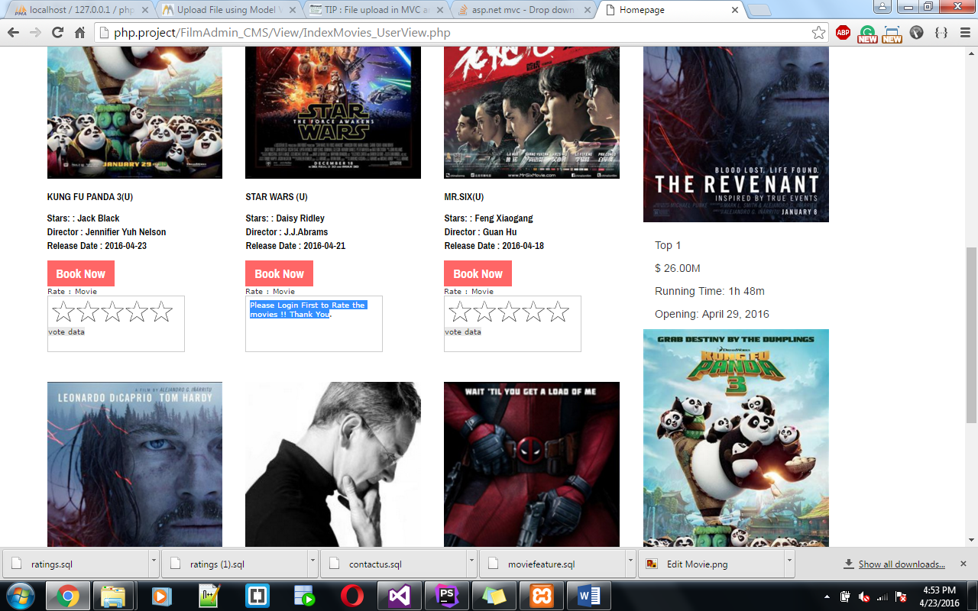

Once you logged in **click on rating:**

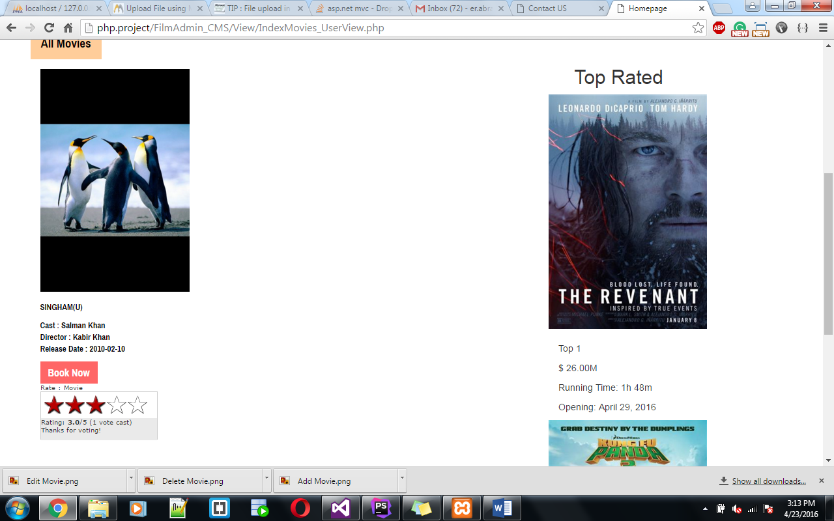

The value inside the brackets shows how many people have voted this movie. It saves **User Id** in database and also create a cookie for this movie ID.so it will not allow user to rate movie again.

**Admin Interface:**

Login as admin and Clickon **Admin Rating**

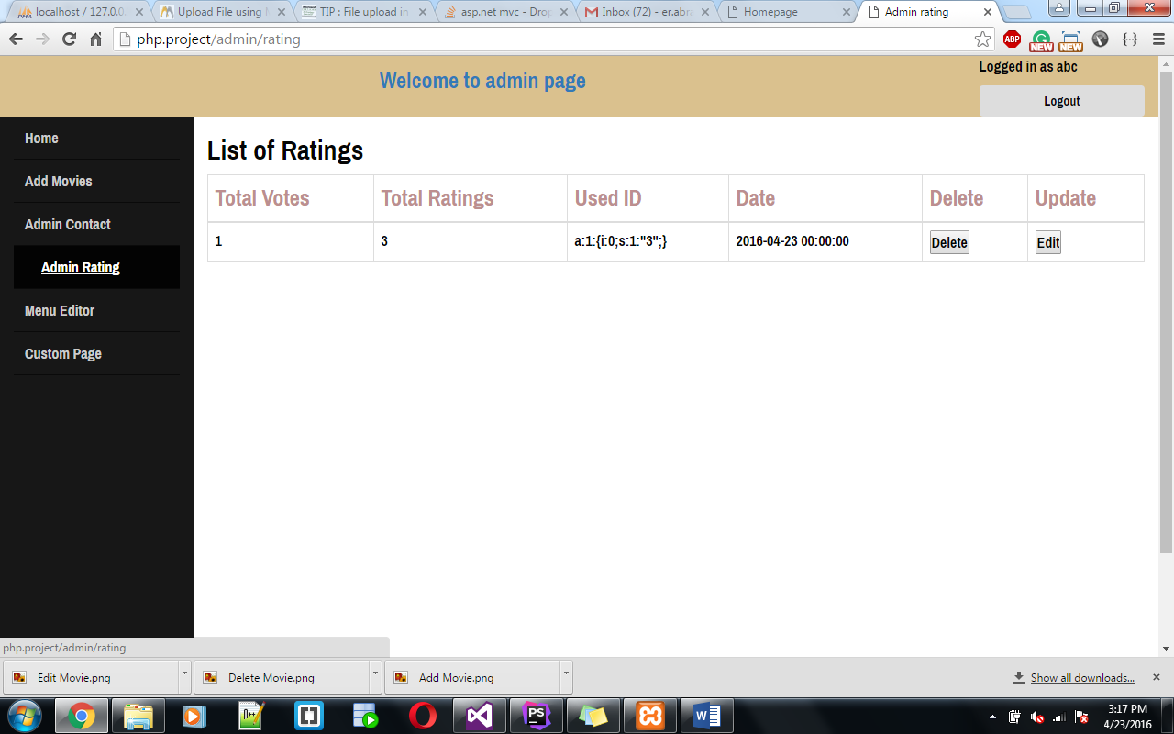

Click on Edit.

Changing Total Votes 1 to 2 and Total Ratings 3 to 5.

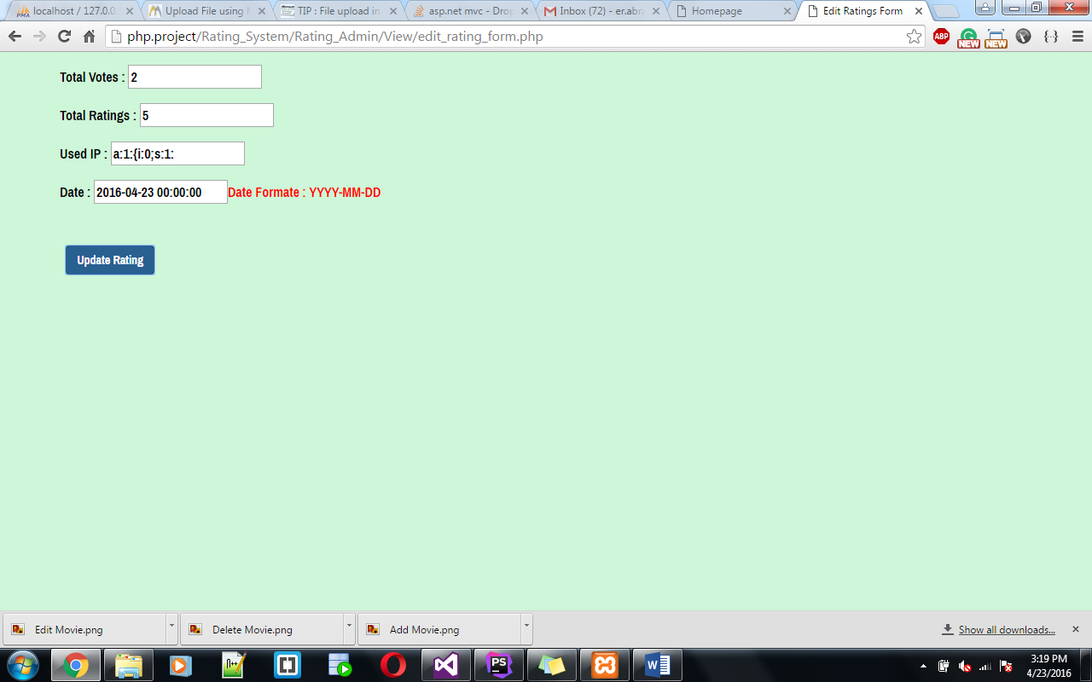

Click on **Update Rating.**

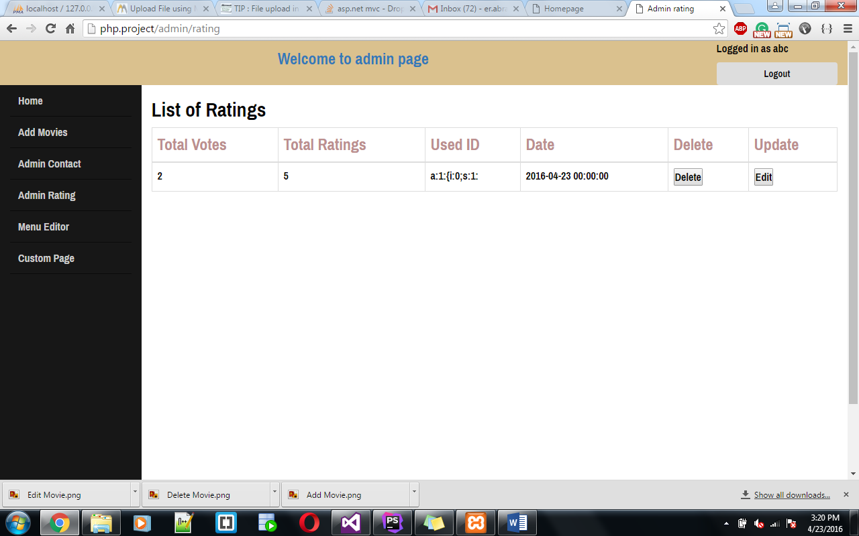

Click on **Delete Button**

